- Trigger for Transformation (Business Challenge) –
My family was all set for a weekend getaway — bags packed, kids buzzing with excitement — until a small fender bender brought it all to a halt. What should’ve been a simple fix turned into a nightmare of phone calls, insurance delays, and repeated visits just to assess the damage.
Around the world, millions of drivers face the same frustration after a minor accident: long waits, paperwork, multiple inspection visits, and unclear repair timelines. From New York to New Delhi, it’s the same outdated process.
That pain isn’t just personal — it's universal. That's why we created Auto Veritas — a smart, AI-powered self-inspection app built on Agent Force, leveraging Salesforce Experience Cloud, Data Cloud, Einstein AI, Slack, and Google APIs.

AUTO VERITAS – “From Breakdown to Breakthrough: Reinventing Vehicle Inspections.
Auto Veritas Team - Aruna Santosh, Shruthi Javare Gowda, Rajkumar Sivan, Maneesh Sai Vadada

- Solution Details

- Technology Stack-

- Experience Cloud:
  - Hosts the self-service portal that allows customers to initiate and track their vehicle inspections.
- AgentForce:
  - Orchestrates the self-service inspection journey for vehicles, guiding users through the process of submitting damage reports.
- Data Cloud:
  - Stores unstructured data in PDF format describing the extent of vehicle damage and associated costs (e.g., Dent - $75, Major Paint Issue - $350, etc.).
  - This data is crucial for accurate assessment and for generating damage reports.
- Slack:
  - Provides real-time alerts to dealers regarding the necessary actions for vehicle bookings and damages.
  - Ensures a smooth communication channel for the dealers to process the information.
- Google API Integration:
  - Uses the Google API to fetch the dealer location based on the customer-provided city.
  - Customers can choose the nearest dealer based on proximity, damage type, and dealer reviews.
- Apex:
  - Handles API callouts to Google for fetching dealer information.
- Flows:
  - A point-and-click solution used to implement the business logic for the inspection process, ensuring efficiency and ease of use.
- Chat GPT:
  - Compares vehicle images (real vs. damage) and generates a detailed damage report.
  - This AI-driven analysis helps assess the vehicle’s condition accurately.
- LWC Components:
  - Provides an interactive user interface, enhancing user experience and facilitating ease of use for both customers and dealers.

- Architecture Overview –

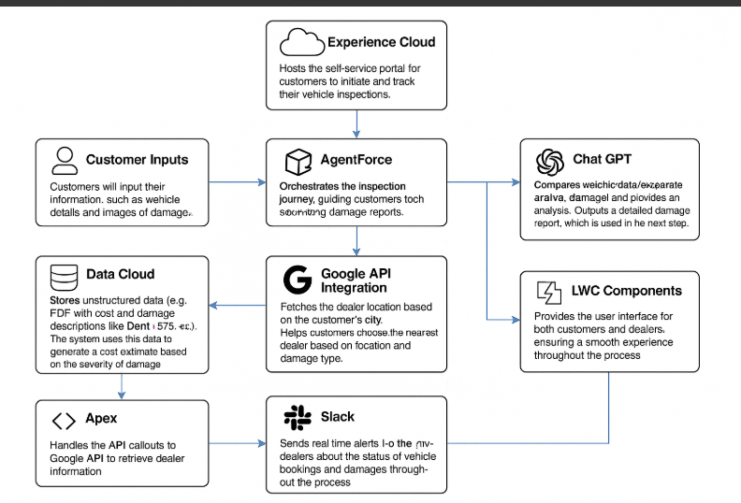

- Customer Journey –
Eg - 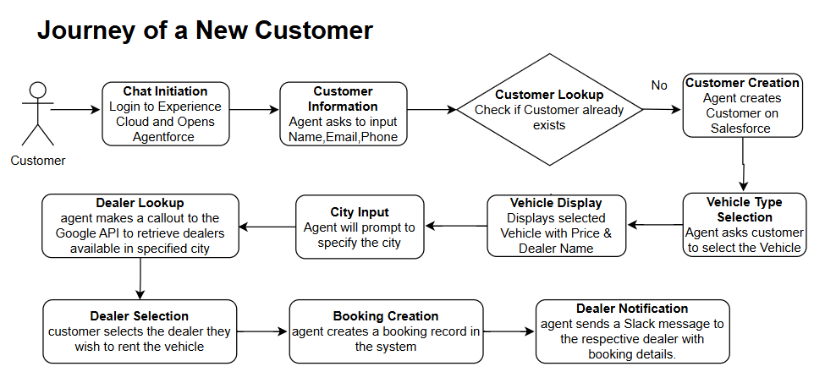

- Technical Details –

- Flow Name: Check New Existing Customer
Description: Checks for existing customer based on email, if customer does not exist it will create new customer. If a customer exists it will return the vehicle booking request available for that customer.

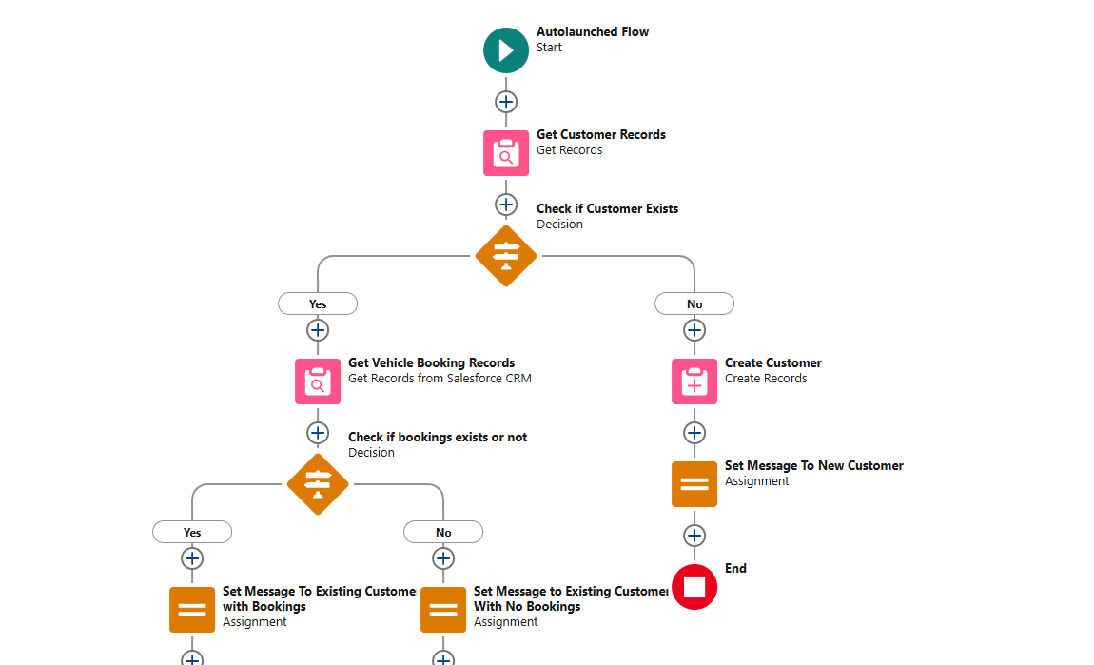

- Flow Name : Get_Vehicle_Details
Description : It will return the list of vehicle available based on type of vehicle.
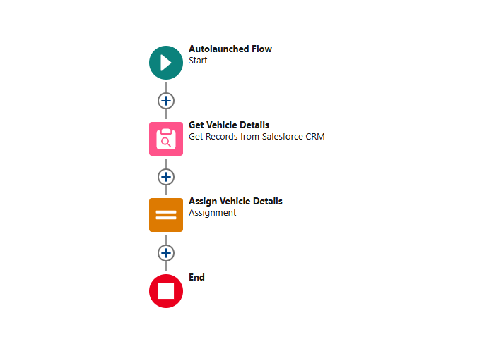
- Flow Name: Create Vehicle Record Booking
Description: It will creates the vehicle booking record for the respective customer.
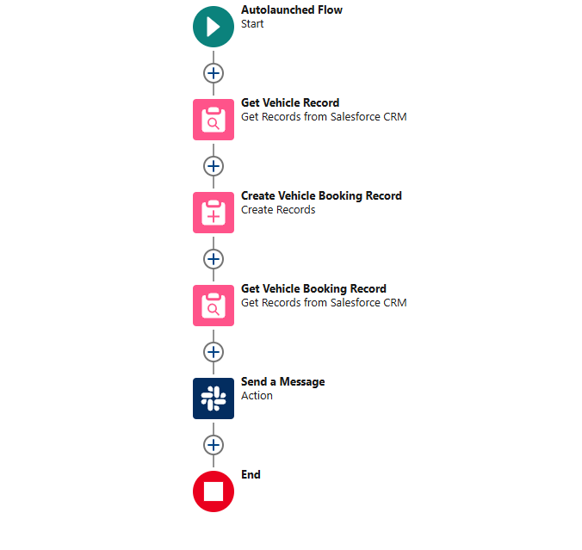
- Flow Name : Get Existing Customer Bookings
Description: It will return the bookings records available for the respective customer.
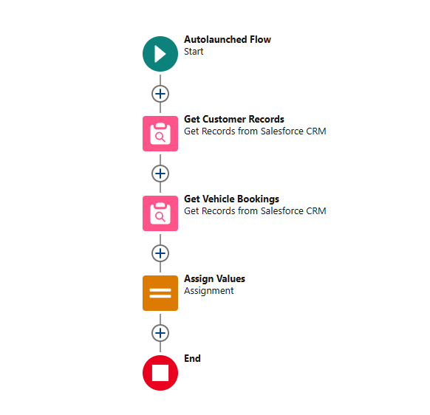
- Flow Name : Create Self Assessment Record.
Description : It will create the self assessment to respective booking record.
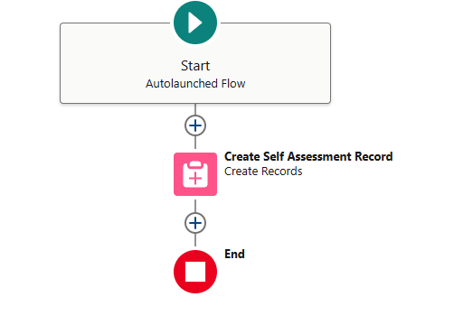
- Flow Name : Create Vehicle Check In
Description: It will create the vehicle check in record for the respective booking record.
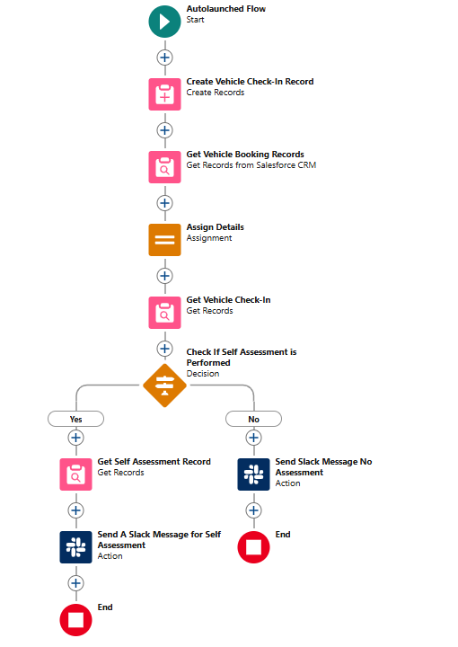

- Apex class Name: GoogleAPIResponseWrapper
Description : Wrapper to hold the response received by Google API.
- 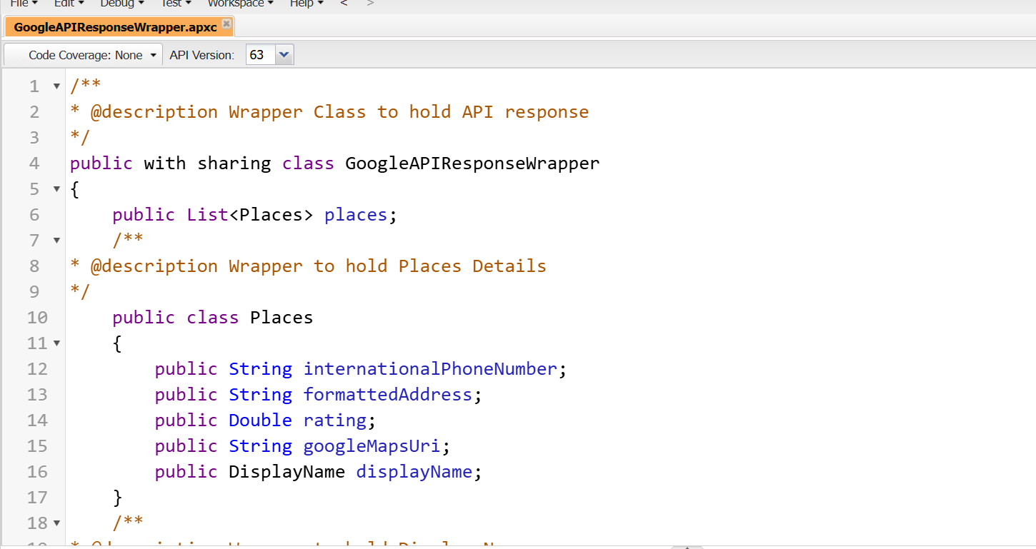
- Apex class Name : GoogleAPIIntegrator
Description : Class to make the API callout to Google API and fetch the respective dealer available based on the city provided by user and return the response back to the agent.
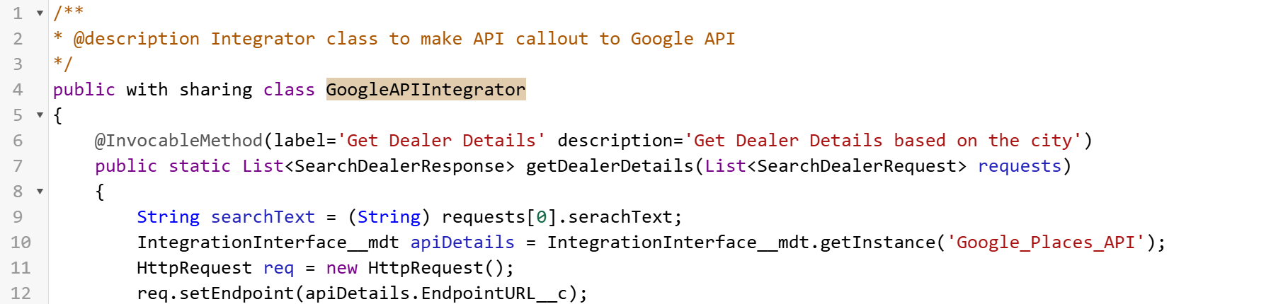

- Apex class Name : VerifyImageAndAssessDamage
Description : Class to make API callout to Chat GPT and fetch the damage report by comparing original image and damage image and return the response back to the agent.
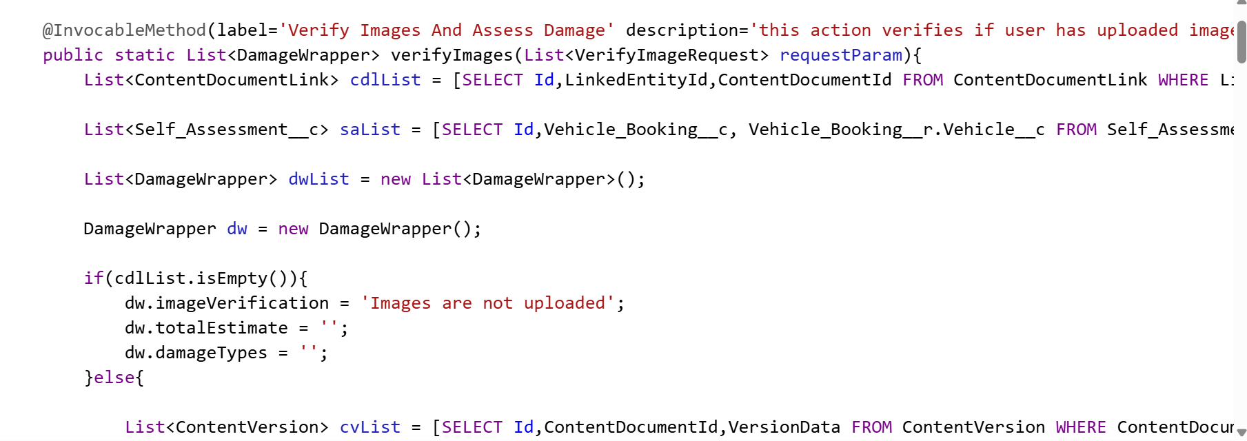

- Apex class : FileUploadController
Description : It will add the damage car image uploaded by the user to the Self assessment record.
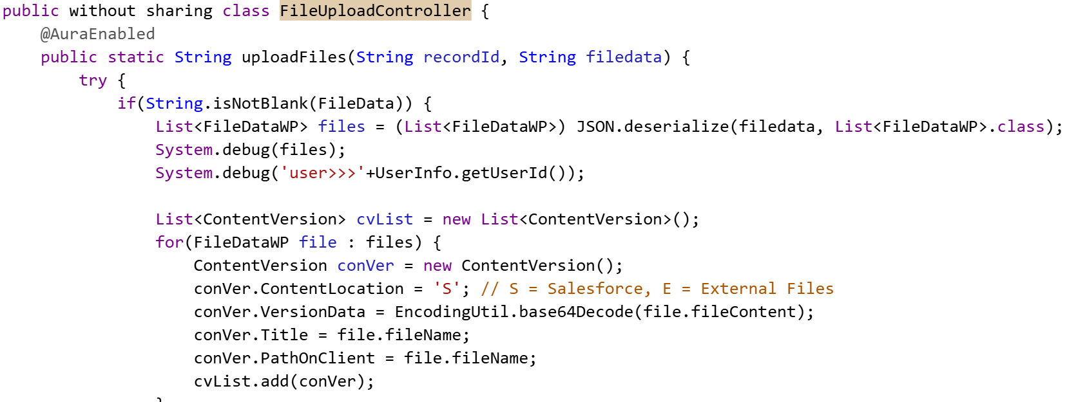

- LWC Name : carRentalHome
Description : Used this lwc for implementing Experience cloud home page.
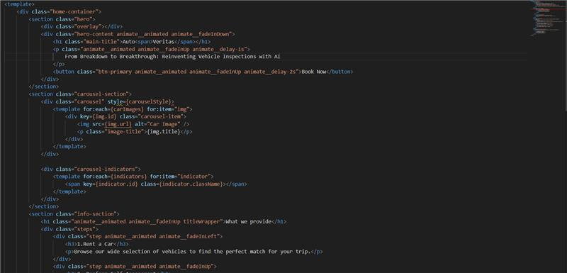

- LWC Name : imageUpload
Description : : It will add the damage car image uploaded by the user to the Self assessment record.
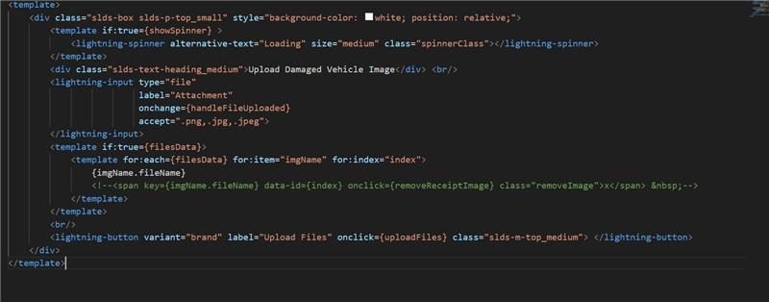

- What’s the road ahead? (Enhancements)
While the solution has already made a significant impact, we aim to enhance it further:
- Expand Inspection Scope:
  - Currently focused on exterior damages, we plan to extend the inspection capabilities to include interior issues like odometer problems, window issues, and rearview mirror defects.
- Multi-Angle Image Uploads:
  - Instead of a single reference image, we want to enable customers to upload images from multiple angles to provide a more comprehensive view of the vehicle damage.
- Automated Customer Engagement:
  - We plan to enhance customer satisfaction by integrating automated emails with invoice details, promotional offers, and other relevant information.

